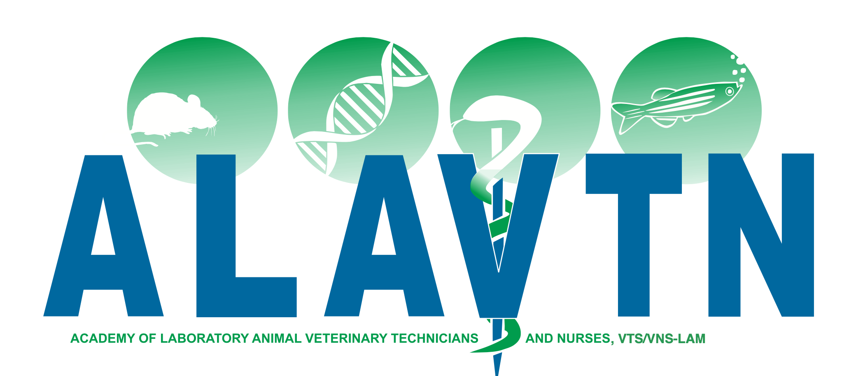
The Academy of Laboratory Animal Veterinary Technicians and Nurses
2018 Application
Name: |  |  |  |  | Degrees:
Address: |  |  |  |  | City:
 |  |  |  |  | State/Province:
Zip: | Country if other that USA:
Phone: | How long in the lab animal  field at 70% or more time:
Secondary phone: | Please check the following species nursing category you are applying for: Traditional Species  Large Animal Non-traditional Species  Research Surgeon Research Anesthetist
Email:
Employment History for the last 5 years.
(Include all facilities where cases will be represented in the case logs.)
Date hired: |  | Date left: |  |  |  | At least 38hrs a week?
Employer: |  |  |  | Position:
Supervisor: |  |  | Contact email:
Address: |  |  |  |  |  | Years or months at facility:
Date hired: |  | Date left: |  |  |  | At least 38hrs a week?
Employer: |  |  |  | Position:
Supervisor: |  |  | Contact email:
Address: |  |  |  |  |  | Years or months at facility:
Date hired: |  | Date left: |  |  |  | At least 38hrs a week?
Employer: |  |  |  | Position:
Supervisor: |  |  | Contact email:
Address: |  |  |  |  |  | Years or months at facility:

Date hired: | Date left: |  |  | At least 38hrs a week?
Employer: |  |  | Position:
Supervisor: |  | Contact email:
Address: |  |  |  | Years or months at facility:
Date hired: | Date left: |  |  | At least 38hrs a week?
Employer: |  |  | Position:
Supervisor: |  | Contact email:
Address: |  |  |  | Years or months at facility:
Date hired: | Date left: |  |  | At least 38hrs a week?
Employer: |  |  | Position:
Supervisor: |  | Contact email:
Address: |  |  |  | Years or months at facility:
AVMA Accredited School and graduation date (if applicable):

The application fee is $50 and is non-refundable, even if you do not get your application accepted.  Checks must be received prior |  |  |  | NAVTA membership #:
Please make checks payable to: “ The Society of Laboratory Animal Veterinary Technicians” with “ALAVTN app” on the notes section. |  |  | Send Checks to:  Stephen Cital  3314 Lindenoaks Drive, San Jose CA 95117

